1. Brief Description of what topic or technology you are concentrating on within this journal.

We are looking at different forms of dynamic routing(RIPv2, OSPF, EIGRP).

2. Topology import:

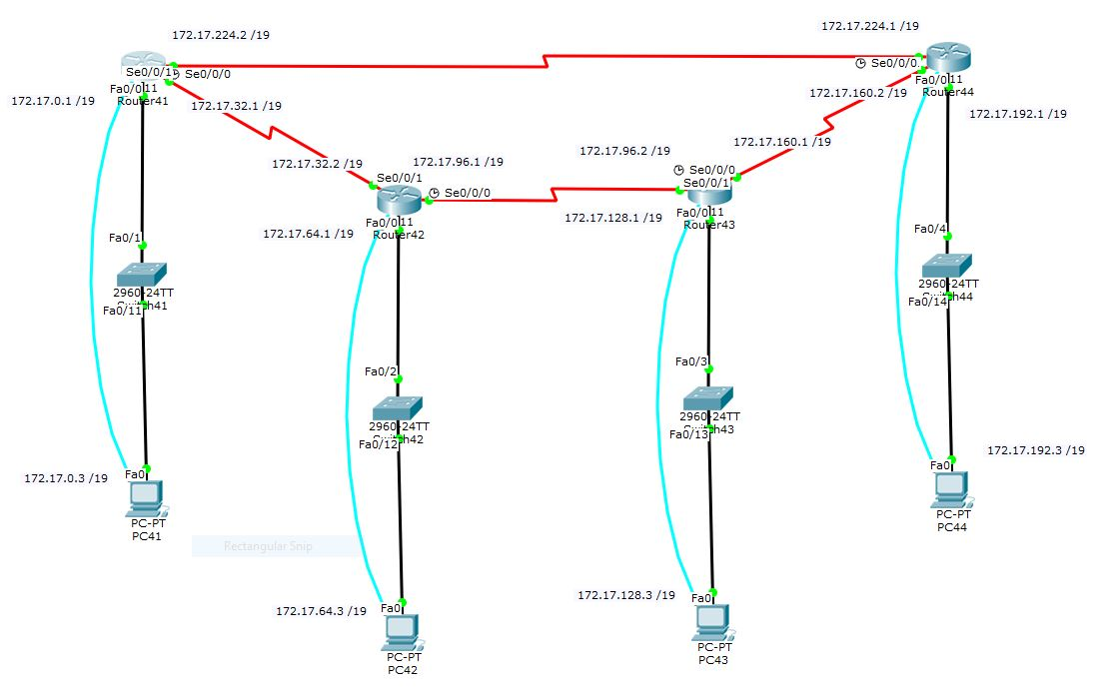

3. Table of Command Syntax and the associated description:

|  |  |
| --- | --- |
| Command | Description |
| Router rip | Enable rip configuration mode |
| Network X.X.X.X | Add a network into the rip table |
| Version X | Specify the rip version |
| Router ospf X | Enable ospf configuration mode on process id X |
| Network x.x.x.x y.y.y.y area z | Add network into ospf table with wildcard mask of y marked as area z |
| No auto-summary | Disable automatic summarization |

4. Verification (ie: ping, tracert, traceroute tools and output)

RIPv2:

Router41:

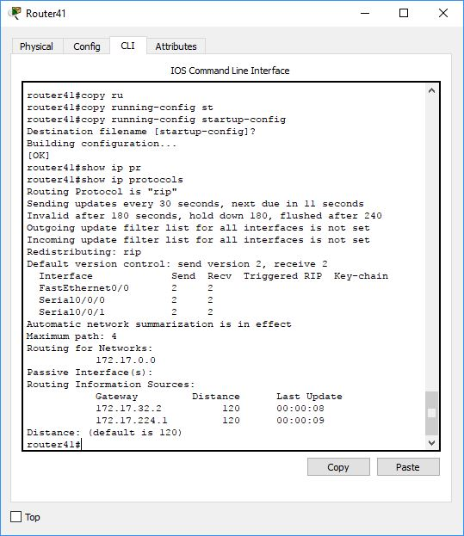

Router 42:

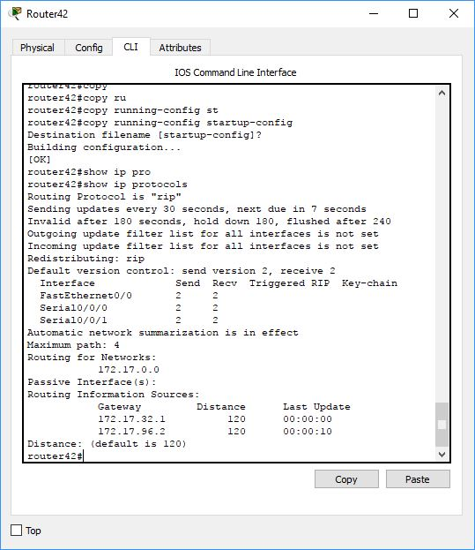

Router 43:

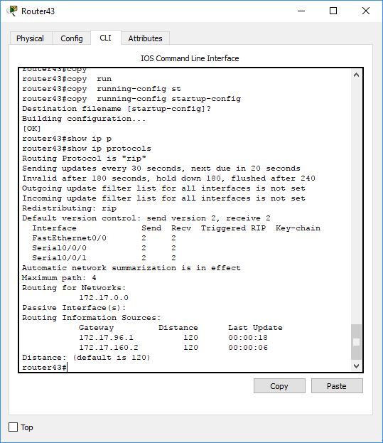

Router 44:

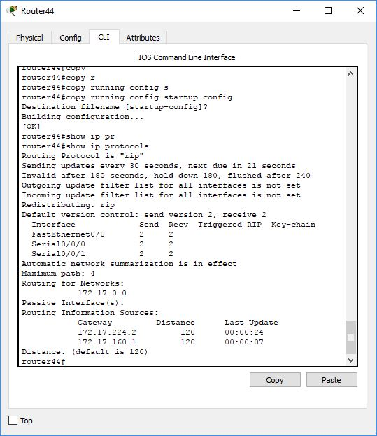

Pc 41 to all other pc’s:

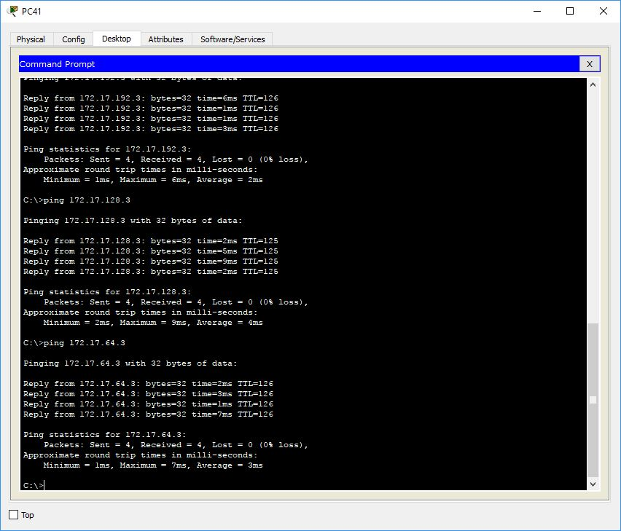

OSPF:

Router 41:

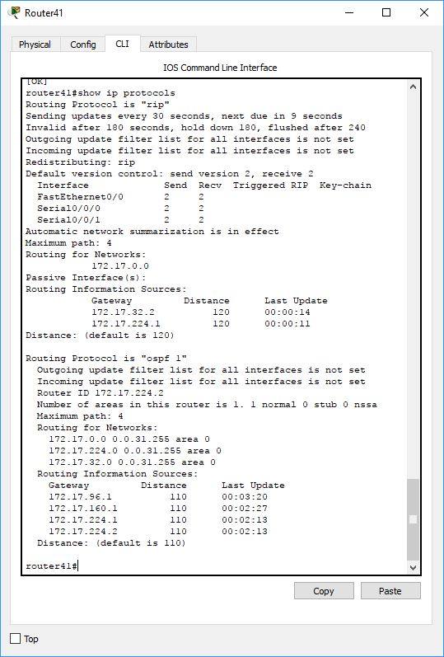

Router 42:

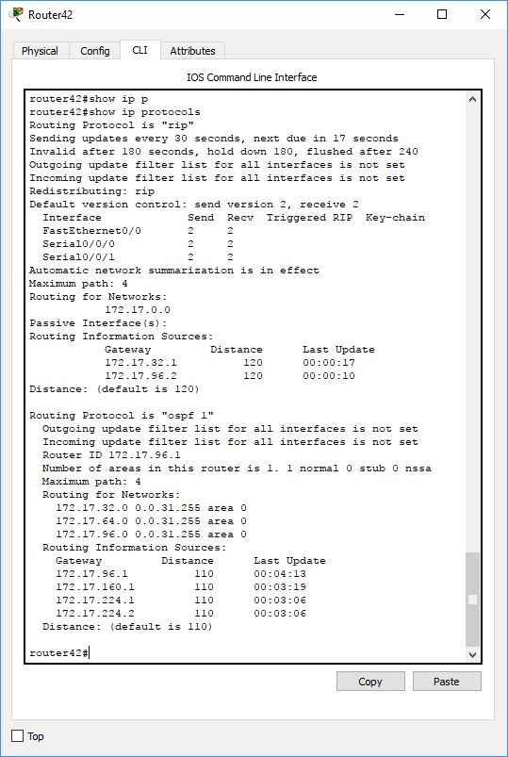

Router 43:

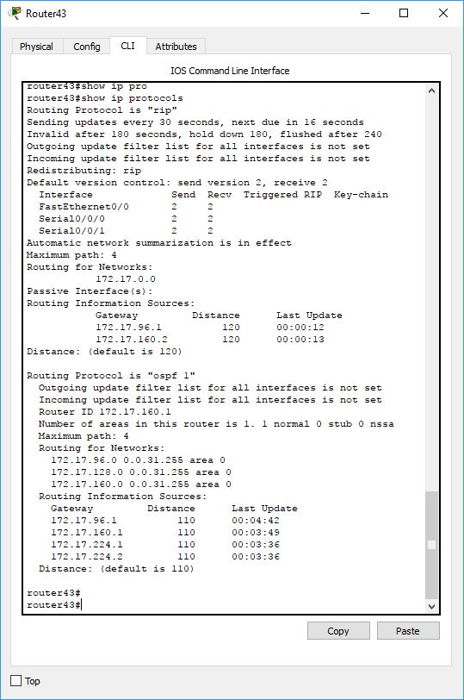

Router 44:

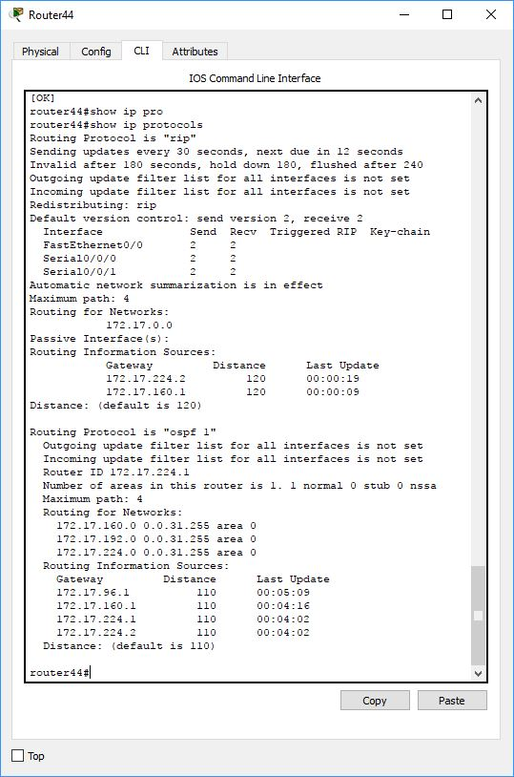

EIGRP:

Router41 final routing table:

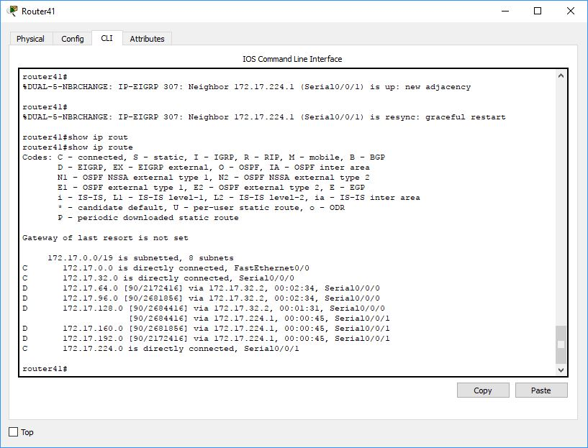

Router42 final routing table:

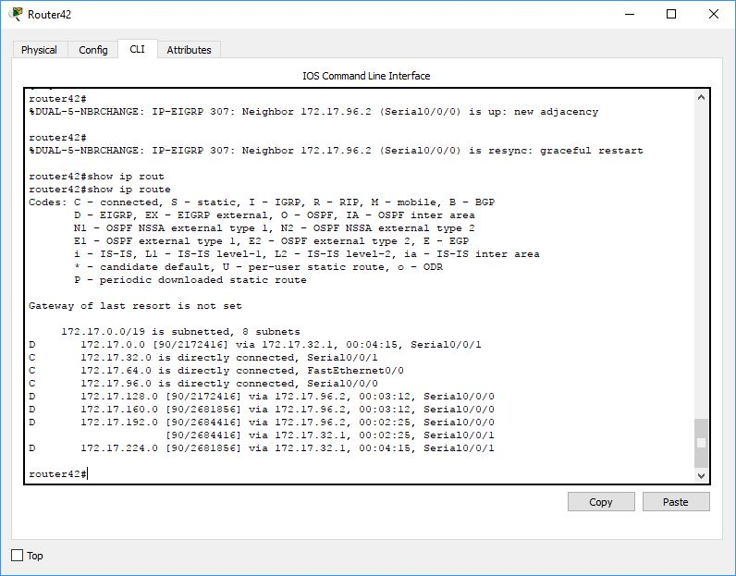

Router43 final routing table:

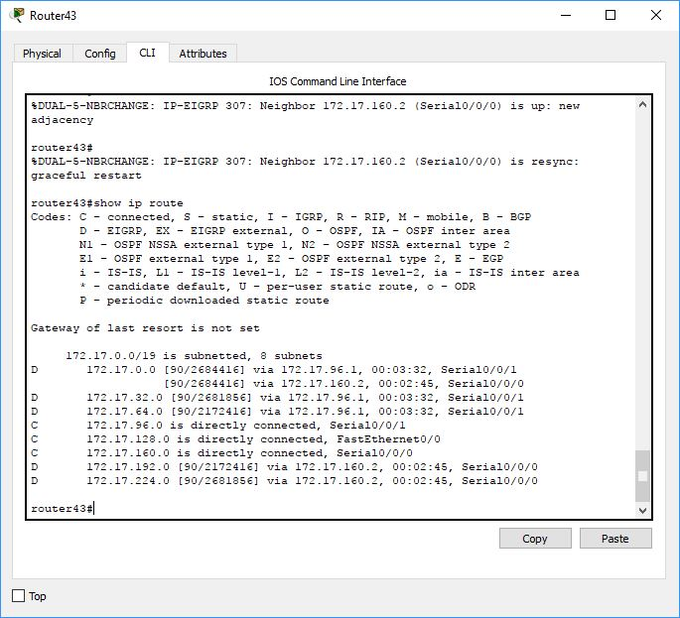

Router44 final routing table:

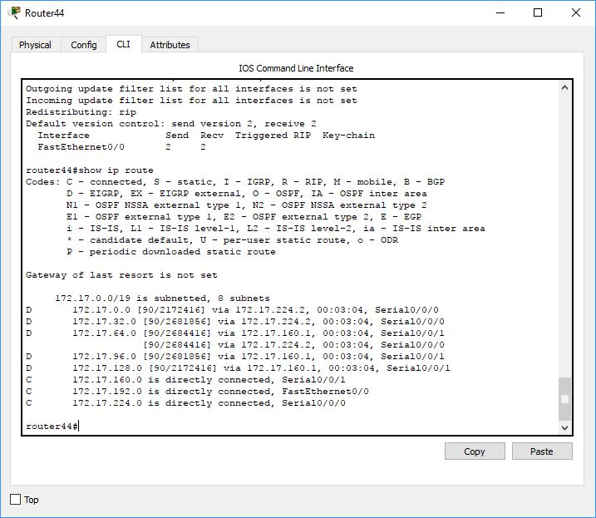

5. Results / Outcomes

In the end everything seemed to work correctly. The first time I tried EIGRP I was unable to ping other pc’s anymore. After restarting the routers and re trying I was able to again. This would leave me to believe I miss typed something the first time.